Bahria University,

Karachi Campus



COURSE: CEL-221 Computer Architecture And Organization

TERM: FALL 2020, CLASS: BSE- 3 (A)

Submitted By:

_______________________________________________

(ADIL WAHEED) (65190)

Submitted To:

Engr. Muhammed Rehan Baig

Signed Remarks: Score:

INDEX

|  |  |  |  |  |
| --- | --- | --- | --- | --- |
| SNO | DATE | LAB NO | LAB OBJECTIVE | SIGN |
| 1 | **19 October 2020** | 1 | **INTRODUCTION TO VVM** |  |
| 2 | **19 October 2020** | 2 | **Introduction to VVM Programming** |  |
| 3 | **24 October 2020** | 3 | **VVM Programming** |  |
| 4 | **24 October 2020** | 4 | **Introduction to MIPS Assembly language** |  |
| 5 | **30 October 2020** | 5 | **MIPS ASSEMBLY LANGUAGE ARITHMETIC OPERATIONS** |  |
| 6 | **30 October 2020** | 6 | **MIPS ASSEMBLY LANGUAGE USING ADDU INSTRUCTION** |  |
| 7 | **8 November 2020** | 7 | **Arithmetic Instructions in MIPS** |  |
| 8 | **14 November 2020** | 8 | **MULTIPLICATION AND DIVISION INSTRUCTIONS IN MIPS** |  |
| 9 | **27 December 2020** | 9 | **BIT MANIPULATION INSTRUCTIONS IN MIPS** |  |
|  |  |  |  |  |
|  |  |  |  |  |
|  |  |  |  |  |
|  |  |  |  |  |
| SNO | DATE | LAB NO | LAB OBJECTIVE | SIGN |
|  |  |  |  |  |
|  |  |  |  |  |
|  |  |  |  |  |
|  |  |  |  |  |
|  |  |  |  |  |
|  |  |  |  |  |
|  |  |  |  |  |
|  |  |  |  |  |
|  |  |  |  |  |
|  |  |  |  |  |
|  |  |  |  |  |
|  |  |  |  |  |

Bahria University,

Karachi Campus



LAB EXPERIMENT NO.

___09____

LIST OF TASKS

|  |  |
| --- | --- |
| TASK NO | OBJECTIVE |
| 1 | Complete the table by solving the bitwise instruction of all Logical gates. Add the code and output of the logical gates to show solution of MASK BITS given in the table. |
|  |  |
|  |  |
|  |  |
|  |  |

Submitted On:

____________

(Date: 27/12/20)

**Task No 1:** **Complete the table by solving the bitwise instruction of all Logical**

**gates. Add the code and output of the logical gates to show solution**

**of MASK BITS given in the table.**

**Solution:**

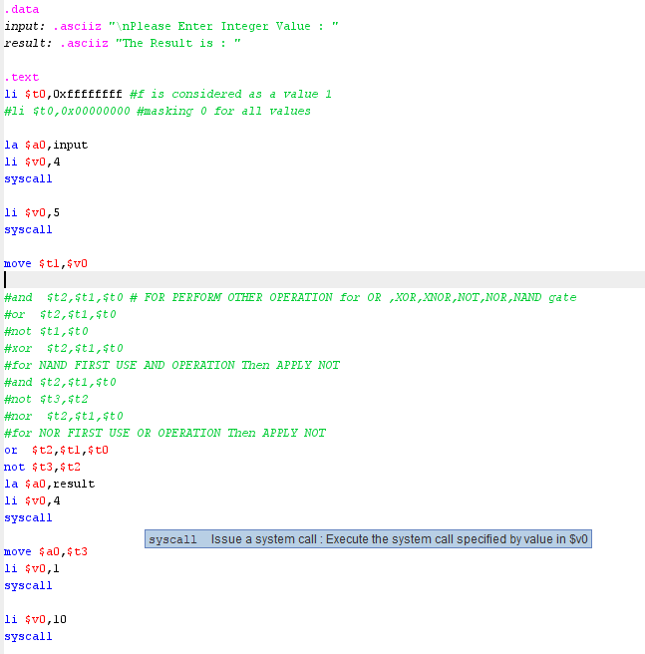

**OUTPUT:**

|  |  |  |
| --- | --- | --- |
| **LOGIC** | **Mask Bits** | |
|  | **0** | **1** |
| **AND** |  |  |
| **OR** |  |  |
| **NOT** |  |  |
| **XOR** |  |  |
| **XNOR** |  |  |
| **NOR** |  |  |
| **NAND** |  |  |